CREATE TABLE:

1.SAILOR

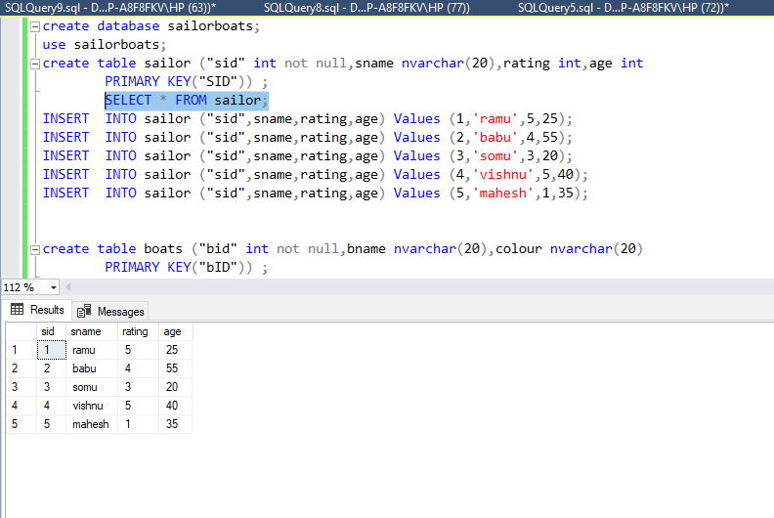

2.BOATS

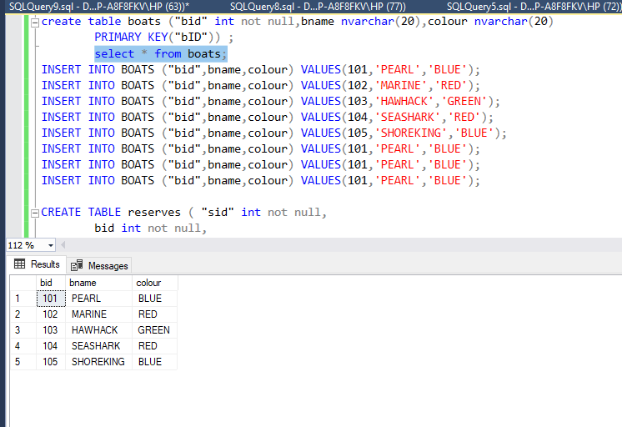

3.RESERVES

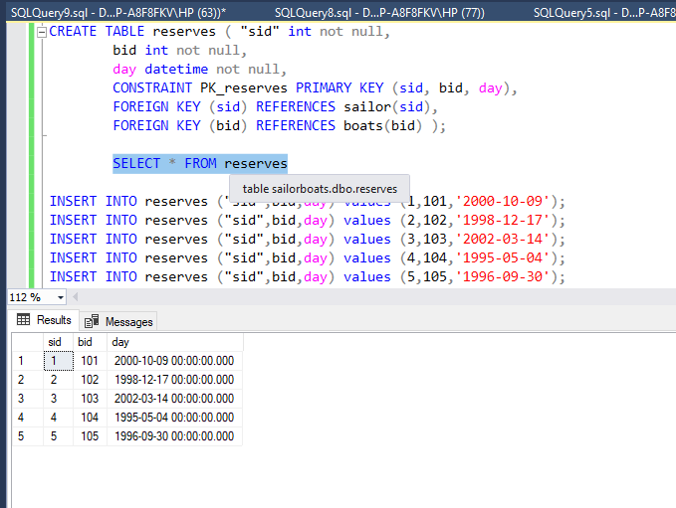

1. LIST OF SAILORS IN DESCENDING ORDER OF THEIR RATING:

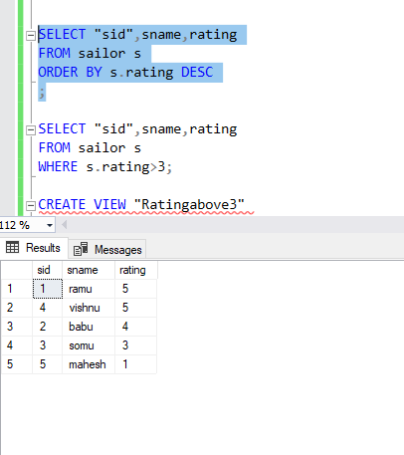

1. View of sailors rating greater than 3

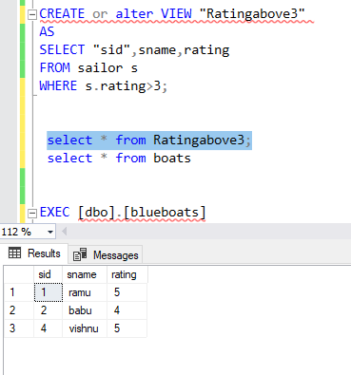

1. PROCEDURE TO DISPLAY BLUE COLOR BOAT

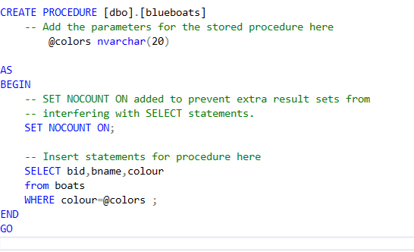

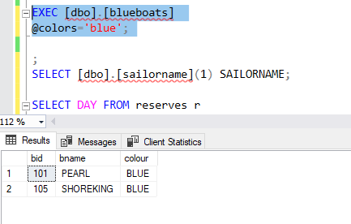

1. BOATS ALONG WITH NUMBER OF BOATS

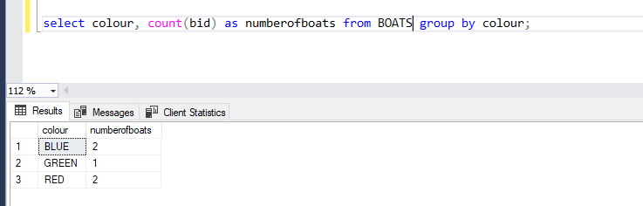

1. FUNCTION THAT ACCEPTS SID AND RETURNS NAME

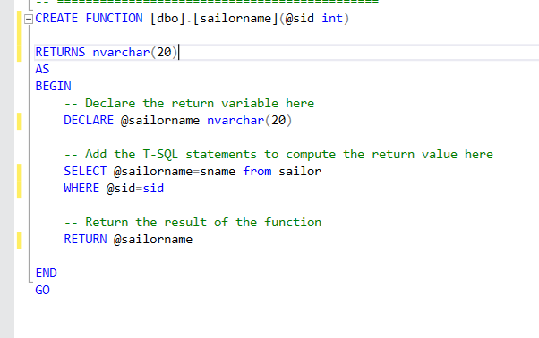

SELECT [dbo].[sailorname](1) SAILORNAME;

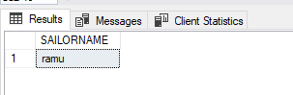

1. DATES IN WHICH GREEN COLOR BOAT IS RESERVED

SELECT DAY FROM reserves r

JOIN boats b

on r.bid=b.bid where colour='green';

